**Module 5**

* The application layer is the last and 7th layer from the bottom of the OSI model.
* It is a layer through which the end user can communicate directly with the software.
* The application layer transmits the data in the form of a user-readable format. It provides many services to the user. It transfers data to the presentation layer. Furthermore, it either provides services to the presentation layer or takes services from the presentation layer.

Not only that, but it is the responsibility of the application layer that the communication between two hosts is taken place smoothly without any disturbance. The application layer ensures that the required media is available on both hosts. It determines which protocol is to be used while communicating between the hosts.

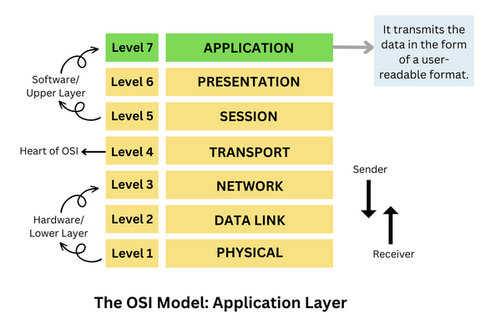

**Functions of the application layer in the OSI model**

* Application Layer provides a facility by which users can forward several emails and it also provides a storage facility.
* This layer allows users to access, retrieve and manage files in a remote computer.
* It allows users to log on as a remote host.
* This layer provides services which include: e-mail, transferring files, distributing results to the user, directory services, network resources and so on.
* It provides protocols that allow software to send and receive information and present meaningful data to users.
* It handles issues such as network transparency, resource allocation and so on.
* This layer serves as a window for users and application processes to access network services.
* The application layer is actually an abstraction layer that specifies the shared protocols and interface methods used by hosts in a communication network.
* This layer allows users to interact with other software applications.
* In this layer, data is in visual form, which makes users truly understand data rather than remembering or visualize the data in the binary format (0’s or 1’s).
* This application layer basically interacts with Operating System (OS) and thus further preserves the data in a suitable manner.
* This layer also receives and preserves data from it’s previous layer, which is Presentation Layer (which carries in itself the syntax and semantics of the information transmitted).
* The protocols which are used in this application layer depend upon what information users wish to send or receive.
* This layer communicates with the operating system and guarantees that data is saved properly.

## Protocols of the application layer in the OSI model:

# FTP

**FTP (File Transfer Protocol)** is a standard network protocol used for the transfer of files from one host to another over a TCP-based network, such as the Internet.

## Why FTP?

Although transferring files from one system to another is very simple and straightforward, but sometimes it can cause problems. For example, two systems may have different file conventions. Two systems may have different ways to represent text and data. Two systems may have different directory structures. FTP protocol overcomes these problems by establishing two connections between hosts. One connection is used for data transfer, and another connection is used for the control connection.

## Mechanism of FTP

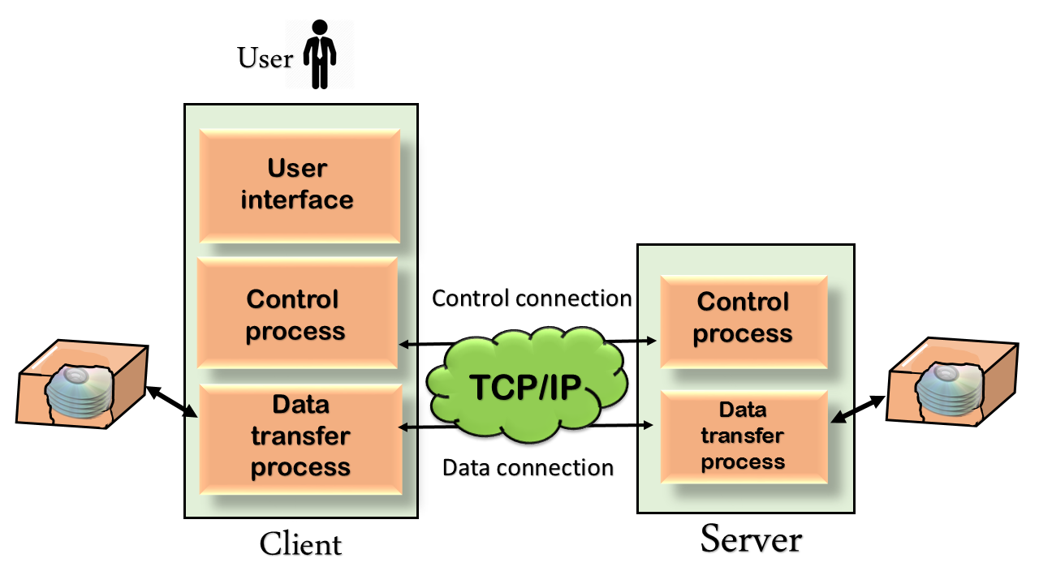

The above figure shows the basic model of the FTP. The FTP client has three components: the user interface, control process, and data transfer process. The server has two components: the server control process and the server data transfer process.

**There are two types of connections in FTP:**

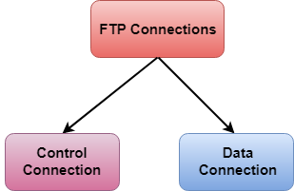

* **Control Connection:** The control connection uses very simple rules for communication. Through control connection, we can transfer a line of command or line of response at a time. The control connection is made between the control processes. The control connection remains connected during the entire interactive FTP session.

For sending control information like user identification, password, commands to change the remote directory, commands to retrieve and store files, etc., FTP makes use of a control connection. The control connection is initiated on port number 21.

* **Data Connection:** The Data Connection uses very complex rules as data types may vary. The data connection is made between data transfer processes. The data connection opens when a command comes for transferring the files and closes when the file is transferred.

For sending the actual file, FTP makes use of a data connection. A data connection is initiated on port number 20.

# DNS

An application layer protocol defines how the application processes running on different systems, pass the messages to each other.

* DNS stands for Domain Name System.
* DNS is a directory service that provides a mapping between the name of a host on the network and its numerical address.
* DNS is required for the functioning of the internet.
* Each node in a tree has a domain name, and a full domain name is a sequence of symbols specified by dots.
* DNS is a service that translates the domain name into IP addresses. This allows the users of networks to utilize user-friendly names when looking for other hosts instead of remembering the IP addresses.
* For example, suppose the FTP site at EduSoft had an IP address of 132.147.165.50, most people would reach this site by specifying ftp.EduSoft.com. Therefore, the domain name is more reliable than IP address.

DNS is a TCP/IP protocol used on different platforms. The domain name space is divided into three different sections: generic domains, country domains, and inverse domain.

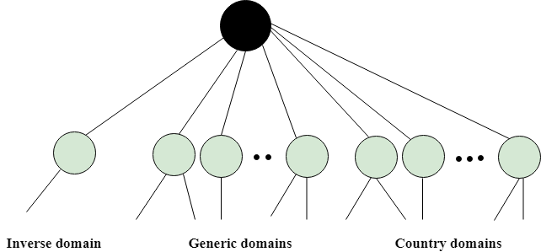

## Generic Domains

* It defines the registered hosts according to their generic behavior.
* Each node in a tree defines the domain name, which is an index to the DNS database.
* It uses three-character labels, and these labels describe the organization type.

|  |  |
| --- | --- |
| **Label** | **Description** |
| aero | Airlines and aerospace companies |
| biz | Businesses or firms |
| com | Commercial Organizations |
| coop | Cooperative business Organizations |
| edu | Educational institutions |
| gov | Government institutions |
| info | Information service providers |
| int | International Organizations |
| mil | Military groups |
| museum | Museum & other nonprofit organizations |
| name | Personal names |
| net | Network Support centers |
| org | Nonprofit Organizations |
| pro | Professional individual Organizations |

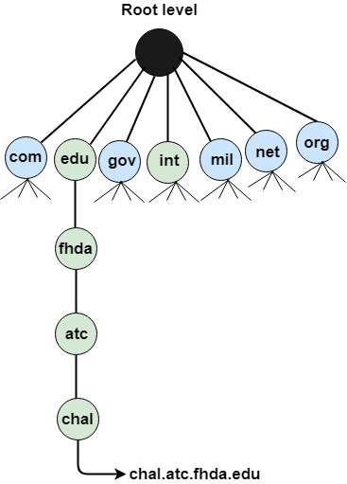

## Country Domain

The format of country domain is same as a generic domain, but it uses two-character country abbreviations (e.g., us for the United States) in place of three character organizational abbreviations.

## Inverse Domain

The inverse domain is used for mapping an address to a name. When the server has received a request from the client, and the server contains the files of only authorized clients. To determine whether the client is on the authorized list or not, it sends a query to the DNS server and ask for mapping an address to the name.

## Working of DNS

* DNS is a client/server network communication protocol. DNS clients send requests to the. server while DNS servers send responses to the client.
* Client requests contain a name which is converted into an IP address known as a forward DNS lookups while requests containing an IP address which is converted into a name known as reverse DNS lookups.
* DNS implements a distributed database to store the name of all the hosts available on the internet.
* If a client like a web browser sends a request containing a hostname, then a piece of software such as **DNS resolver** sends a request to the DNS server to obtain the IP address of a hostname. If DNS server does not contain the IP address associated with a hostname, then it forwards the request to another DNS server. If IP address has arrived at the resolver, which in turn completes the request over the internet protocol.

# HTTP

* HTTP stands for **HyperText Transfer Protocol**.
* It is a protocol used to access the data on the World Wide Web (www).
* The HTTP protocol can be used to transfer the data in the form of plain text, hypertext, audio, video, and so on.
* HTTP is similar to the FTP as it also transfers the files from one host to another host. But, HTTP is simpler than FTP as HTTP uses only one connection, i.e., no control connection to transfer the files.
* HTTP is used to carry the data in the form of MIME-like format.

## Features of HTTP:

* **Connectionless protocol:** HTTP is a connectionless protocol. HTTP client initiates a request and waits for a response from the server. When the server receives the request, the server processes the request and sends back the response to the HTTP client after which the client disconnects the connection. The connection between client and server exist only during the current request and response time only.
* **Media independent:** HTTP protocol is a media independent as data can be sent as long as both the client and server know how to handle the data content. It is required for both the client and server to specify the content type in MIME-type header.
* **Stateless:** HTTP is a stateless protocol as both the client and server know each other only during the current request. Due to this nature of the protocol, both the client and server do not retain the information between various requests of the web pages.

## HTTP Transactions

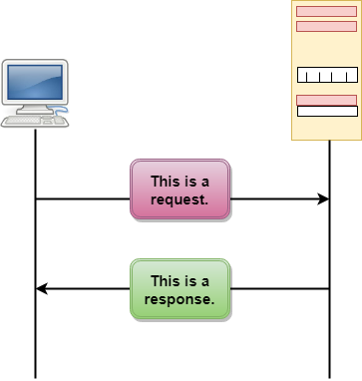

The above figure shows the HTTP transaction between client and server. The client initiates a transaction by sending a request message to the server. The server replies to the request message by sending a response message.

## Messages

HTTP messages are of two types: request and response. Both the message types follow the same message format.

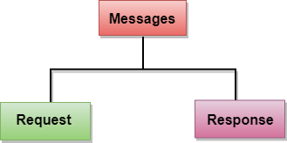

**Request Message:** The request message is sent by the client that consists of a request line, headers, and sometimes a body.

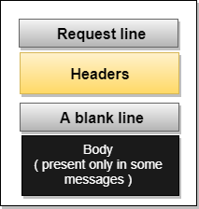

**Response Message:** The response message is sent by the server to the client that consists of a status line, headers, and sometimes a body.

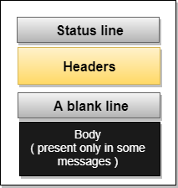

## Uniform Resource Locator (URL)

* A client that wants to access the document in an internet needs an address and to facilitate the access of documents, the HTTP uses the concept of Uniform Resource Locator (URL).
* The Uniform Resource Locator (URL) is a standard way of specifying any kind of information on the internet.
* The URL defines four parts: method, host computer, port, and path.

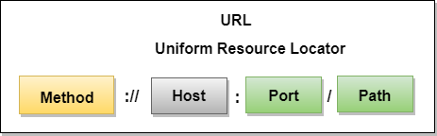

* **Method:** The method is the protocol used to retrieve the document from a server. For example, HTTP.
* **Host:** The host is the computer where the information is stored, and the computer is given an alias name. Web pages are mainly stored in the computers and the computers are given an alias name that begins with the characters "www". This field is not mandatory.
* **Port:** The URL can also contain the port number of the server, but it's an optional field. If the port number is included, then it must come between the host and path and it should be separated from the host by a colon.
* **Path:** Path is the pathname of the file where the information is stored. The path itself contain slashes that separate the directories from the subdirectories and files.

# SMTP

* SMTP stands for Simple Mail Transfer Protocol.
* SMTP is a set of communication guidelines that allow software to transmit an electronic mail over the internet is called **Simple Mail Transfer Protocol**.
* It is a program used for sending messages to other computer users based on e-mail addresses.
* It provides a mail exchange between users on the same or different computers, and it also supports:
  + It can send a single message to one or more recipients.
  + Sending message can include text, voice, video or graphics.
  + It can also send the messages on networks outside the internet.
* The main purpose of SMTP is used to set up communication rules between servers. The servers have a way of identifying themselves and announcing what kind of communication they are trying to perform. They also have a way of handling the errors such as incorrect email address. For example, if the recipient address is wrong, then receiving server reply with an error message of some kind.

## Components of SMTP

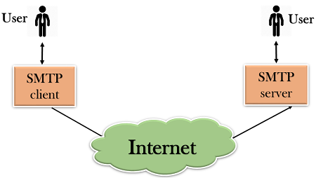

* First, we will break the SMTP client and SMTP server into two components such as user agent (UA) and mail transfer agent (MTA). The user agent (UA) prepares the message, creates the envelope and then puts the message in the envelope. The mail transfer agent (MTA) transfers this mail across the internet.

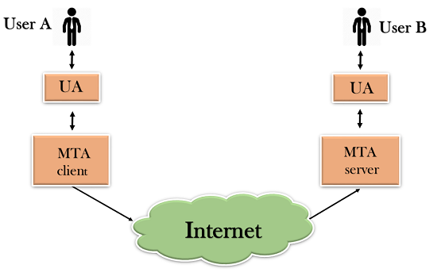

* SMTP allows a more complex system by adding a relaying system. Instead of just having one MTA at sending side and one at receiving side, more MTAs can be added, acting either as a client or server to relay the email.

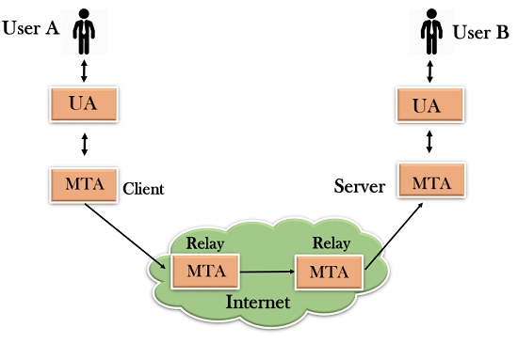

* The relaying system without TCP/IP protocol can also be used to send the emails to users, and this is achieved by the use of the mail gateway. The mail gateway is a relay MTA that can be used to receive an email.

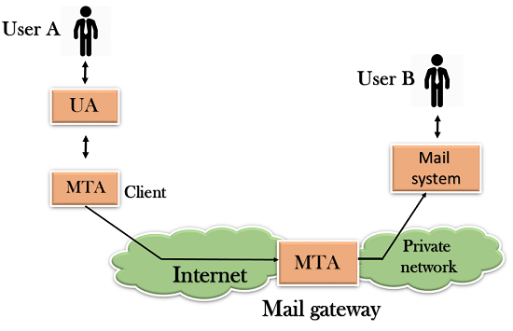

## Working of SMTP

1. **Composition of Mail:** A user sends an e-mail by composing an electronic mail message using a Mail User Agent (MUA). Mail User Agent is a program which is used to send and receive mail. The message contains two parts: body and header. The body is the main part of the message while the header includes information such as the sender and recipient address. The header also includes descriptive information such as the subject of the message. In this case, the message body is like a letter and header is like an envelope that contains the recipient's address.
2. **Submission of Mail:** After composing an email, the mail client then submits the completed e-mail to the SMTP server by using SMTP on TCP port 25.
3. **Delivery of Mail:** E-mail addresses contain two parts: username of the recipient and domain name. For example, vivek@gmail.com, where "vivek" is the username of the recipient and "gmail.com" is the domain name.  
   If the domain name of the recipient's email address is different from the sender's domain name, then MSA will send the mail to the Mail Transfer Agent (MTA). To relay the email, the MTA will find the target domain. It checks the MX record from Domain Name System to obtain the target domain. The MX record contains the domain name and IP address of the recipient's domain. Once the record is located, MTA connects to the exchange server to relay the message.
4. **Receipt and Processing of Mail:** Once the incoming message is received, the exchange server delivers it to the incoming server (Mail Delivery Agent) which stores the e-mail where it waits for the user to retrieve it.
5. **Access and Retrieval of Mail:** The stored email in MDA can be retrieved by using MUA (Mail User Agent). MUA can be accessed by using login and password.

# SNMP

* SNMP stands for **Simple Network Management Protocol**.
* SNMP is a framework used for managing devices on the internet.
* It provides a set of operations for monitoring and managing the internet.

## SNMP Concept

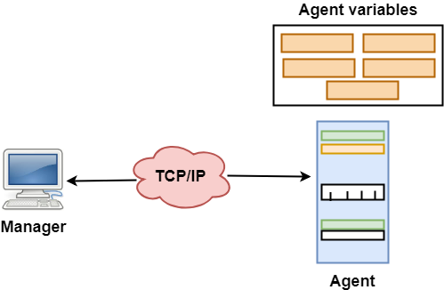

* SNMP has two components Manager and agent.
* The manager is a host that controls and monitors a set of agents such as routers.
* It is an application layer protocol in which a few manager stations can handle a set of agents.
* The protocol designed at the application level can monitor the devices made by different manufacturers and installed on different physical networks.
* It is used in a heterogeneous network made of different LANs and WANs connected by routers or gateways.

## Managers & Agents

* A manager is a host that runs the SNMP client program while the agent is a router that runs the SNMP server program.
* Management of the internet is achieved through simple interaction between a manager and agent.
* The agent is used to keep the information in a database while the manager is used to access the values in the database. For example, a router can store the appropriate variables such as a number of packets received and forwarded while the manager can compare these variables to determine whether the router is congested or not.
* Agents can also contribute to the management process. A server program on the agent checks the environment, if something goes wrong, the agent sends a warning message to the manager.

## Management with SNMP has three basic ideas:

* A manager checks the agent by requesting the information that reflects the behavior of the agent.
* A manager also forces the agent to perform a certain function by resetting values in the agent database.
* An agent also contributes to the management process by warning the manager regarding an unusual condition.

## Management Components

* Management is not achieved only through the SNMP protocol but also the use of other protocols that can cooperate with the SNMP protocol. Management is achieved through the use of the other two protocols: SMI (Structure of management information) and MIB(management information base).
* Management is a combination of SMI, MIB, and SNMP. All these three protocols such as abstract syntax notation 1 (ASN.1) and basic encoding rules (BER).

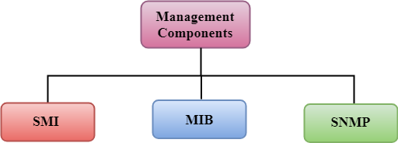

### SMI

The SMI (Structure of management information) is a component used in network management. Its main function is to define the type of data that can be stored in an object and to show how to encode the data for the transmission over a network.

### MIB

* The MIB (Management information base) is a second component for the network management.
* Each agent has its own MIB, which is a collection of all the objects that the manager can manage. MIB is categorized into eight groups: system, interface, address translation, ip, icmp, tcp, udp, and egp. These groups are under the mib object.

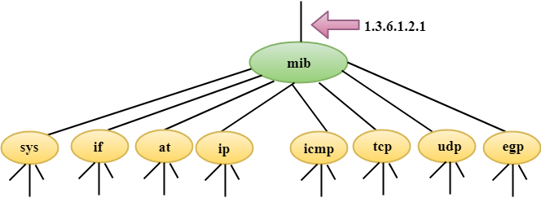

### SNMP

SNMP defines five types of messages: GetRequest, GetNextRequest, SetRequest, GetResponse, and Trap.

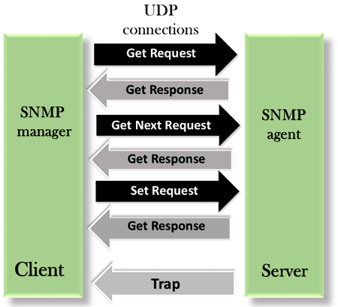

**GetRequest:** The GetRequest message is sent from a manager (client) to the agent (server) to retrieve the value of a variable.

**GetNextRequest:** The GetNextRequest message is sent from the manager to agent to retrieve the value of a variable. This type of message is used to retrieve the values of the entries in a table. If the manager does not know the indexes of the entries, then it will not be able to retrieve the values. In such situations, GetNextRequest message is used to define an object.

**GetResponse:** The GetResponse message is sent from an agent to the manager in response to the GetRequest and GetNextRequest message. This message contains the value of a variable requested by the manager.

**SetRequest:** The SetRequest message is sent from a manager to the agent to set a value in a variable.

**Trap:** The Trap message is sent from an agent to the manager to report an event. For example, if the agent is rebooted, then it informs the manager as well as sends the time of rebooting.

TELNET

**TELNET** stands for **Tel**etype **Net**work. It is a type of protocol that enables one computer to connect to the local computer. It is used as a standard [**TCP/IP protocol**](https://www.geeksforgeeks.org/tcp-ip-in-computer-networking/) for virtual terminal service which is provided by [**ISO**](https://www.geeksforgeeks.org/iso-full-form/). The computer which starts the connection is known as the **local computer**.

The computer which is being connected to i.e. which accepts the connection known as the **remote computer**.

During telnet operation, whatever is being performed on the remote computer will be displayed by the local computer. Telnet operates on a client/server principle. The local computer uses a telnet client program and the remote computers use a telnet server program.

## Logging

The logging process can be further categorized into two parts:

1. Local Login
2. Remote Login

**1. Local Login:** Whenever a user logs into its local system, it is known as local login.

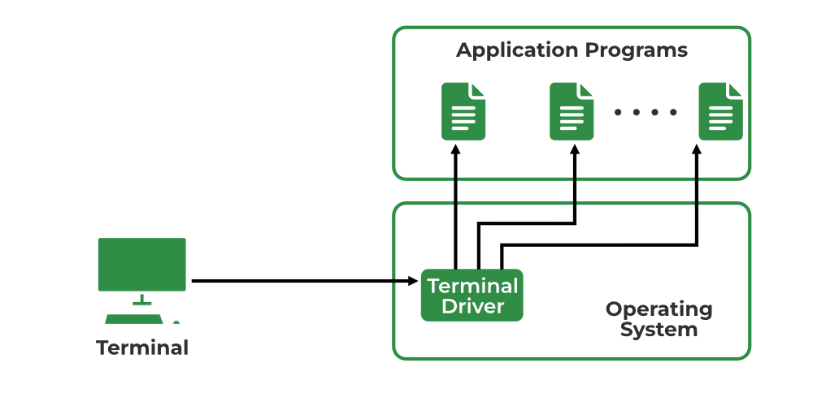

Local Login

**The Procedure of Local Login**

* Keystrokes are accepted by the terminal driver when the user types at the terminal.
* Terminal Driver passes these characters to OS.
* Now, OS validates the combination of characters and opens the required application.

**2. Remote Login:** [Remote Login](https://www.geeksforgeeks.org/introduction-to-remote-login/) is a process in which users can log in to a remote site i.e. computer and use services that are available on the remote computer. With the help of remote login, a user is able to understand the result of transferring the result of processing from the remote computer to the local computer.

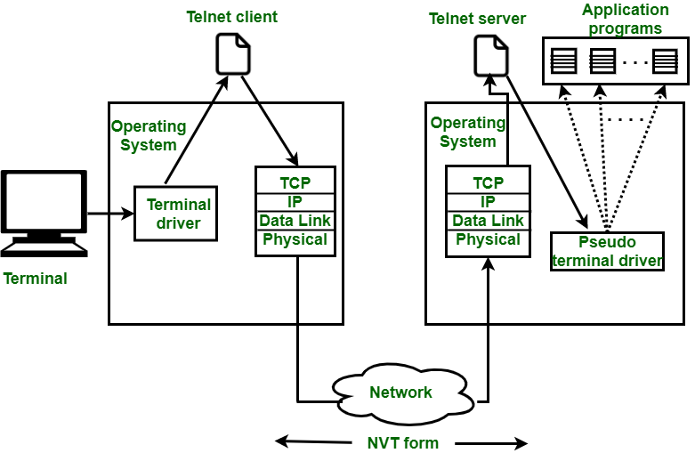

Remote Login in Logging

**The Procedure of Remote Login**

* When the user types something on the local computer, the local operating system accepts the character.
* The local computer does not interpret the characters, it will send them to the TELNET client.
* TELNET client transforms these characters to a universal character set called [Network Virtual Terminal (NVT)](https://www.geeksforgeeks.org/what-is-network-virtual-terminal-in-telnet/) characters and it will pass them to the local TCP/IP protocol Stack.
* Commands or text which are in the form of NVT, travel through the Internet and it will arrive at the [TCP/IP](https://www.geeksforgeeks.org/tcp-ip-model/) stack at the remote computer.
* Characters are then delivered to the operating system and later on passed to the TELNET server.
* Then TELNET server changes those characters to characters that can be understandable by a remote computer.
* The remote operating system receives characters from a pseudo-terminal driver, which is a piece of software that pretends that characters are coming from a terminal.
* The operating system then passes the character to the appropriate application program.